System and actuator constrains for controller design WT Benchmark model

Pitch systems:
Max gradient: 9 deg/s
Min gradient: -9 deg/s
Max pitch 90 deg
Min pitch -2 deg

Converter:
Max torque gradient: 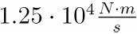
Min torque gradient: 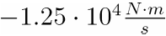
Max torque: 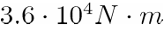
Min torque: 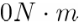

System:
Omega_gen nominel: 162 rad/s (Nominel generator speed)
Soft Max Omega_gen : 186 rad/s (Generator speed should be kept below this value)
Hard Max Omega_gen: 207 rad/s (If generator speed cross this value the wind turbine will be forced to stop for safety reasons).

